Axiom Requisition Copy Service
2869 Jolly Rd, Okemos, Michigan 48864
517.886.5099 – 877.886.5090 toll free – 517.886.4116 facsimile – records@axiomcopy.com

REQUEST FOR RECORDS - ORDER NUMBER 01-26504-010

TO THE CUSTODIAN OF RECORDS Date Sent: November 8, 2026
South Shore Neurologic Associates, P.C.
Dept. Medical Records
77 Medford Avenue (Route 112)
Patchogue, NY 11772
Please find enclosed a request for records of:
Douglas Cortes
DOB 03/30/1972 SSN XXX-XX-8317
We are requesting the following:

FROM 03/30/1972 TO PRESENT: Any and all MEDICAL RECORDS and FILMS (ON CD IF AVAILABLE), including but not limited to patient history forms, etc. pertaining to Douglas Cortes SSN: XXX-XX-8317, DOB: 03/30/1972. DO NOT SEND BILLING RECORDS.

INSTRUCTIONS
- FORWARD INVOICE WITH RECORDS – If fee is greater than $50.00 Pre-approval is required
- PLEASE DO NOT STAPLE DOCUMENTS.
- Mail, email or fax the records to: Axiom Requisition Copy Service (as agent of Christopher Vassallo, McCarthy & Rodriguez), 2869 Jolly Rd, Okemos, MI 48864 – Phone: 517.886.5099 – Fax: (517) 886-4116 – Email: records@axiomcopy.com.

SIGN AND RETURN THIS FORM WITH THE REQUESTED RECORDS
__________________________________________________________
CERTIFICATION OF RECORD SUBMISSION
I certify in response to the request issued to me, that I have submitted a true and complete copy of all requested documents in my control or possession relating to the above person; and that (A) The record was made at or near the time of the occurrence of the matters set forth by, or from information transmitted by, a person with knowledge of those matters; (B) The record was kept in the course of the regularly conducted business activity; and (C) It was the regular practice of the business activity to make the record.

_____________________________________________ _____________________
Signature of the custodian of records Date

If you are sending only part of the documents requested above and some are not in your possession, please check the appropriate boxes below:
- No Medical Records ◻ No X-Ray Films ◻ No Photographs ◻ No Billing Records
If you do not have any of the records requested, please contact our office for an affidavit of no records or send us a letter on your letterhead stating you do not have any of the records requested.

ORDER NUMBER 01-26504-010
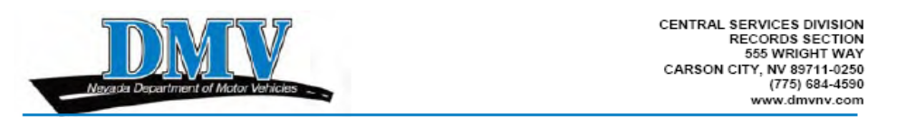
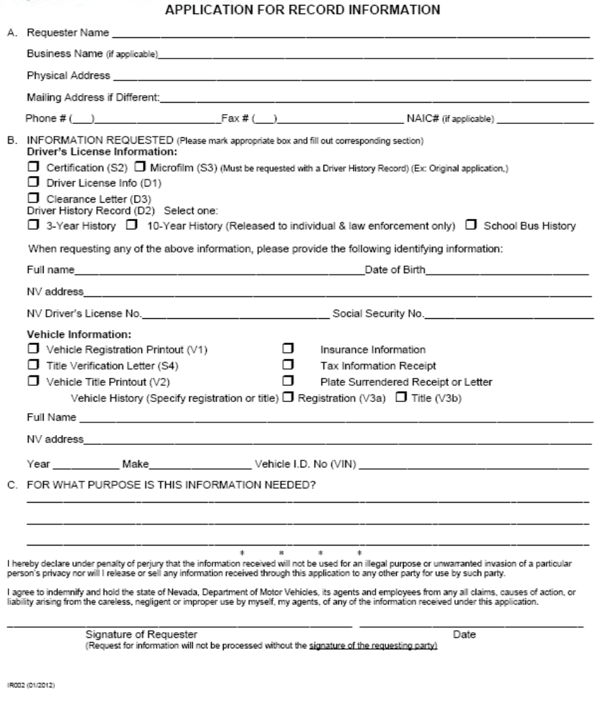
X
X
X
X
Legal Action of Cortes vs. Mongru
Douglas Cortes
03/30/1972

XXX-XX-8317
Axiom Requisition Copy Service (as agent of Christopher Vassallo, McCarthy & Rodriguez)
Axiom Requisition Copy Service
2869 Jolly Rd, Okemos, MI 48864
517.886.5099
(517) 886-4116
Order No. 01-26504 - 010
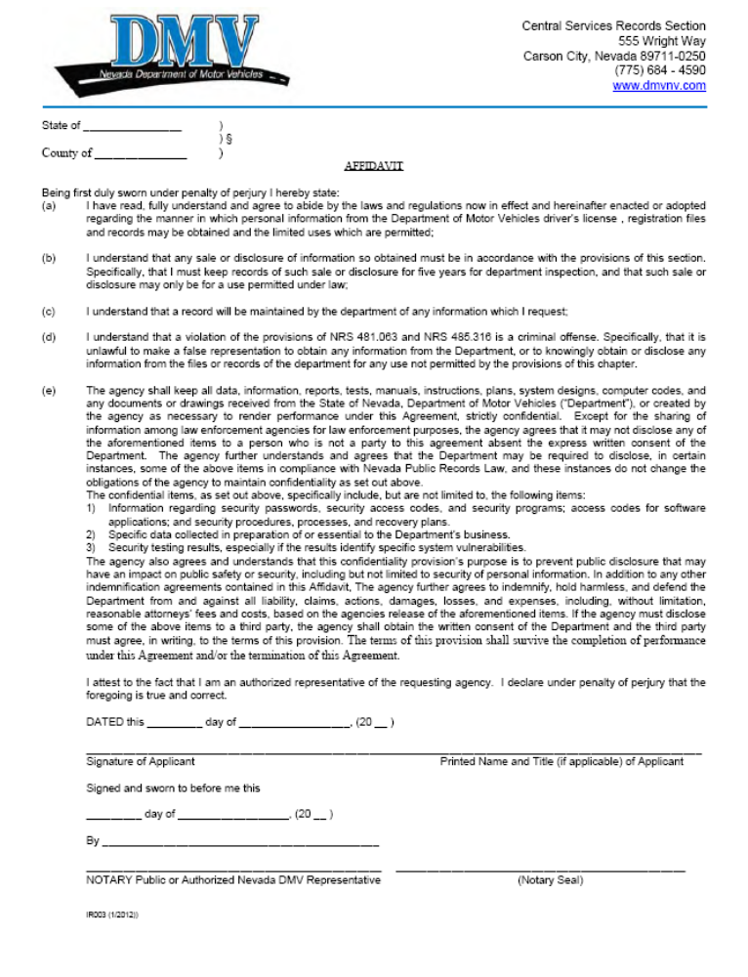
Order No. 01-26504 - 010
Michigan
Ingham
